Spectral coherence: NZDUSD and EURGBP
Method 21 / daily log returns / Welch magnitude-squared coherence / Alpari D1 full available history

Study setup
Logical pair: NZDUSD , EURGBP
Broker symbols: NZDUSD_i , EURGBP_i
Snapshot: 2026-11-03_majors_alpari_D1
Timeframe: D1
Matched return window: 1999-01-06 to 2026-11-02 (UTC bar dates)
Matched return count n: 7183
Dropped unfinished last bar dated 2026-11-03 UTC after a tick-volume check against the prior complete day.
Welch: fs=1.0, nperseg=256, noverlap=128, window=hann, detrend=constant
Headline: gamma^2 nearest f=1/5; also 1/21 and 1/63
Complete matched rows (Excel): NZDUSD-EURGBP_Spectral_D1.xlsx
Complete matched rows (HTML table): NZDUSD-EURGBP_Spectral_D1_data.html

Method carried forward
Magnitude-squared spectral coherence gamma^2(f) measures shared linear power between matched daily log returns of close, ln(close_t / close_t-1), at each frequency f (cycles per day). Quotes are not inverted. Welch settings are frozen: fs=1, nperseg=256, noverlap=128, window=hann, detrend=constant. Headline is gamma^2 at the frequency bin nearest f=1/5 (five-day cycle from the formula sheet). Also reported: gamma^2 nearest f=1/21 and f=1/63, mean gamma^2 over the frequency grid, and phase of the cross-spectrum at the 1/5 bin. Coherence is unsigned (0 to 1); phase carries timing. Same-sample Pearson r is a side check only. This is not causation and not a trading signal.

Results (headline)
gamma^2 near 1/5: 0.011946
bin f (1/5): 0.199219
phase at 1/5 (rad): 0.417536
gamma^2 near 1/21: 0.002260
gamma^2 near 1/63: 0.109677
mean gamma^2: 0.030789
Pearson r: 0.037186

Target-frequency summary
period | target_f | f_bin | gamma2 | phase_rad
5 | 0.2 | 0.19921875 | 0.01194627 | 0.41753599
21 | 0.04761905 | 0.046875 | 0.00225979 | 2.0610464
63 | 0.01587302 | 0.015625 | 0.10967667 | 1.0086102

Conclusion
Headline gamma^2 near f=1/5 for NZDUSD and EURGBP: 0.0119 (bin f=0.199219, phase=0.4175 rad). At ~1/21: 0.0023; at ~1/63: 0.1097. Mean gamma^2 = 0.0308. Pearson r = 0.0372. This is frequency-domain linkage, not a trading signal.

Charts
Daily closes

Daily log returns

Spectral coherence gamma^2(f)
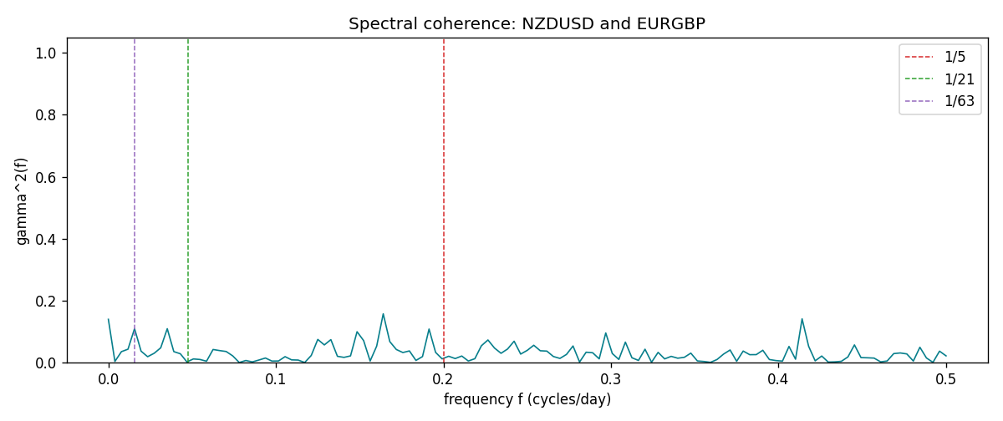

Data report
Matched rows and the coherence sheet are in the sibling Excel workbook named NZDUSD-EURGBP_Spectral_D1.xlsx. Embedding all rows as a Word table is impractical; this file holds column summaries and the first and last 15 matched rows.
Columns: time, NZDUSD_open, EURGBP_open, NZDUSD_high, EURGBP_high, NZDUSD_low, EURGBP_low, NZDUSD_close, EURGBP_close, NZDUSD_tick_volume, EURGBP_tick_volume, NZDUSD_spread, EURGBP_spread, NZDUSD_real_volume, EURGBP_real_volume, NZDUSD_log_return, EURGBP_log_return
Column summaries (matched calculation rows)
column | count | mean | std | min | 25% | 50% | 75% | max
NZDUSD_open | 7183 | 0.65646991 | 0.10818219 | 0.3913 | 0.591455 | 0.6684 | 0.72495 | 0.88218
EURGBP_open | 7183 | 0.78694248 | 0.0966971 | 0.5734 | 0.68755 | 0.83389 | 0.86522 | 0.9769
NZDUSD_high | 7183 | 0.66038812 | 0.10867344 | 0.3961 | 0.5949 | 0.67204 | 0.729365 | 0.88421
EURGBP_high | 7183 | 0.7900202 | 0.09707133 | 0.5789 | 0.6896 | 0.8369 | 0.8681 | 0.9799
NZDUSD_low | 7183 | 0.65278196 | 0.10777661 | 0.3897 | 0.58816 | 0.6642 | 0.720985 | 0.87988
EURGBP_low | 7183 | 0.78424251 | 0.0965143 | 0.5682 | 0.6855 | 0.83166 | 0.86287 | 0.9661
NZDUSD_close | 7183 | 0.65654354 | 0.10817679 | 0.3907 | 0.59181 | 0.6685 | 0.72502 | 0.8822
EURGBP_close | 7183 | 0.78698724 | 0.09669475 | 0.5735 | 0.68775 | 0.83395 | 0.86536 | 0.977
NZDUSD_tick_volume | 7183 | 68736.568 | 123152.54 | 16 | 5594.5 | 33901 | 58513.5 | 1127682
EURGBP_tick_volume | 7183 | 87133.158 | 145499.84 | 154 | 6553 | 44358 | 81413 | 1424684
NZDUSD_spread | 7183 | 30.260755 | 25.633067 | 0 | 9 | 17 | 40 | 80
EURGBP_spread | 7183 | 21.328832 | 19.122264 | 0 | 4 | 13 | 40 | 50
NZDUSD_real_volume | 7183 | 1.6708354e+10 | 8.49951e+10 | 0 | 0 | 0 | 0 | 2.705649e+12
EURGBP_real_volume | 7183 | 2.7872287e+10 | 1.3521454e+11 | 0 | 0 | 0 | 0 | 3.5726265e+12
NZDUSD_log_return | 7183 | 1.073e-05 | 0.0076464 | -0.07027433 | -0.00425909 | 0.00022967 | 0.00458236 | 0.05966839
EURGBP_log_return | 7183 | 2.33e-05 | 0.00487088 | -0.03067367 | -0.00262163 | -9.879e-05 | 0.002558 | 0.06075387
First 15 matched rows (selected columns)
time | NZDUSD_log_return | EURGBP_log_return
1999-01-06 | 0.0020455609 | -0.013303338
1999-01-07 | 0.0062963171 | 0.011051402
1999-01-08 | -0.00055396548 | -0.004943862
1999-01-11 | 0.010290425 | -0.0012752393
1999-01-12 | -0.0053157489 | 0.0033970309
1999-01-13 | -0.0099742238 | 0.00042381861
1999-01-14 | -0.00018564931 | -0.0019793588
1999-01-15 | -0.00074294208 | -0.0076715819
1999-01-18 | -0.0018597736 | 0.00071280921
1999-01-19 | 0.0018597736 | -0.0014261269
1999-01-20 | 0.0040793678 | 0.0019960086
1999-01-21 | 0.0040627941 | -0.00071240297
1999-01-22 | -0.012051689 | -0.0017118406
1999-01-25 | -0.0035504102 | -0.0054402425
1999-01-26 | 0.0072741158 | -0.00057438255
Last 15 matched rows (selected columns)
time | NZDUSD_log_return | EURGBP_log_return
2026-10-13 | 0.0047326165 | 0.00020130374
2026-10-14 | -0.0037306483 | 0.0011241873
2026-10-15 | 0.0047634855 | -0.00087557391
2026-10-16 | 0.0057501001 | -0.0020380844
2026-10-19 | 0.0018917133 | -0.00056950988
2026-10-20 | 0.0037199341 | -0.0035906254
2026-10-21 | 0.0030923331 | -0.00140647
2026-10-22 | -0.0033035227 | -0.0018743924
2026-10-23 | 0.0030929853 | 0.00082421033
2026-10-26 | -0.0028993932 | 0.00013133309
2026-10-27 | -0.00026399852 | -0.0019957343
2026-10-28 | -0.0097283914 | 0.00066967224
2026-10-29 | 0.00062190714 | -0.0011722209
2026-10-30 | 0.00019537668 | -0.0024205543
2026-11-02 | -0.0025962955 | 0.00089940465
First 15 frequency bins
f | gamma2 | phase_rad | period_days
0 | 0.13972033 | 0 | inf
0.00390625 | 0.00373373 | 0.86687297 | 256
0.0078125 | 0.03534792 | -0.05836755 | 128
0.01171875 | 0.04324632 | 0.70482351 | 85.333333
0.015625 | 0.10967667 | 1.0086102 | 64
0.01953125 | 0.03688757 | 0.84689975 | 51.2
0.0234375 | 0.01904543 | 1.612046 | 42.666667
0.02734375 | 0.03009931 | 1.8254295 | 36.571429
0.03125 | 0.04764915 | 0.93509473 | 32
0.03515625 | 0.10948127 | 0.97225548 | 28.444444
0.0390625 | 0.03543219 | 2.0480475 | 25.6
0.04296875 | 0.02845463 | 2.7270661 | 23.272727
0.046875 | 0.00225979 | 2.0610464 | 21.333333
0.05078125 | 0.0117738 | 0.05590129 | 19.692308
0.0546875 | 0.0100213 | 0.90756437 | 18.285714

